**7 - A Hands-on ServiceNow Tool Demo**

**Logging In :**

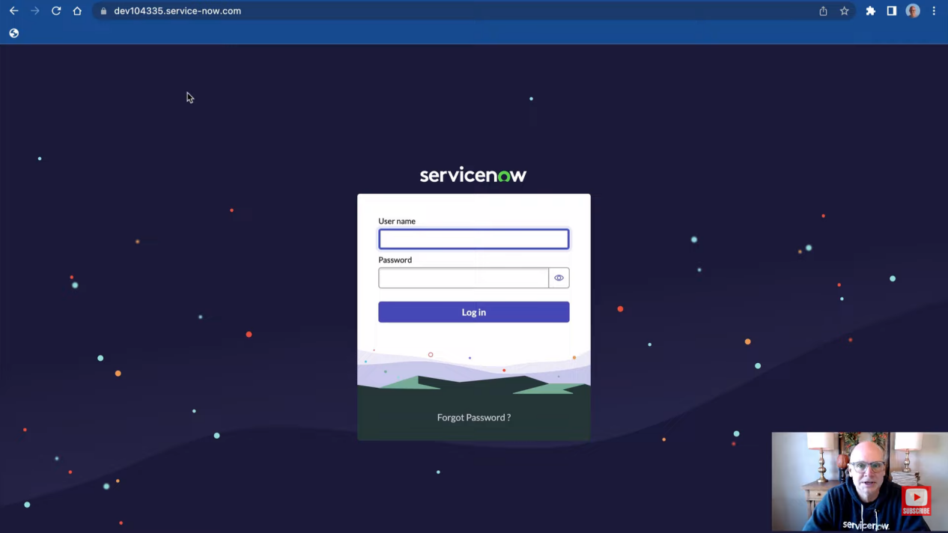

**ServiceNow Next Experience UI :**

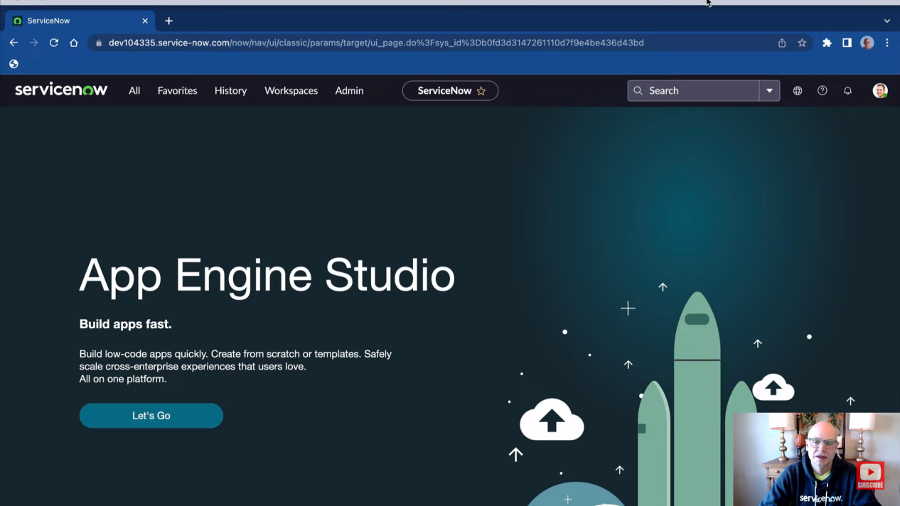

**The navigation Bar :**



**Application Navigator :**

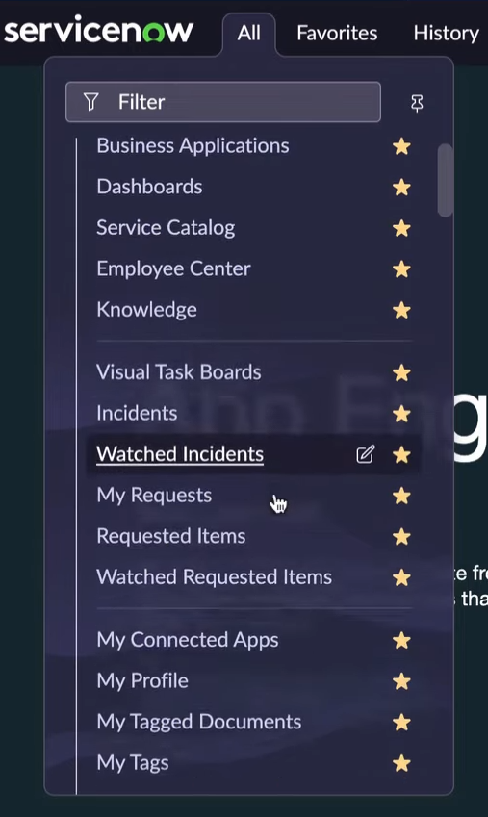

**The ServiceNow Store :**

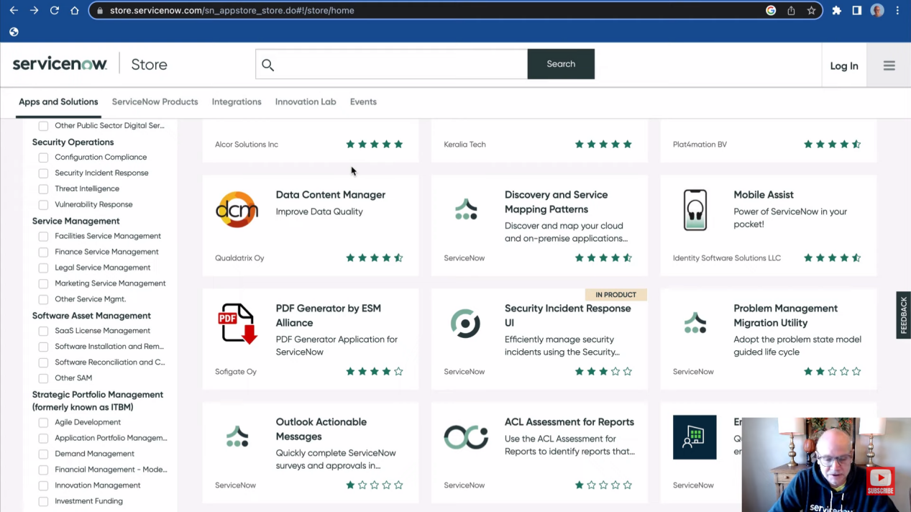

**ServiceNow Application Training and Certifications :**

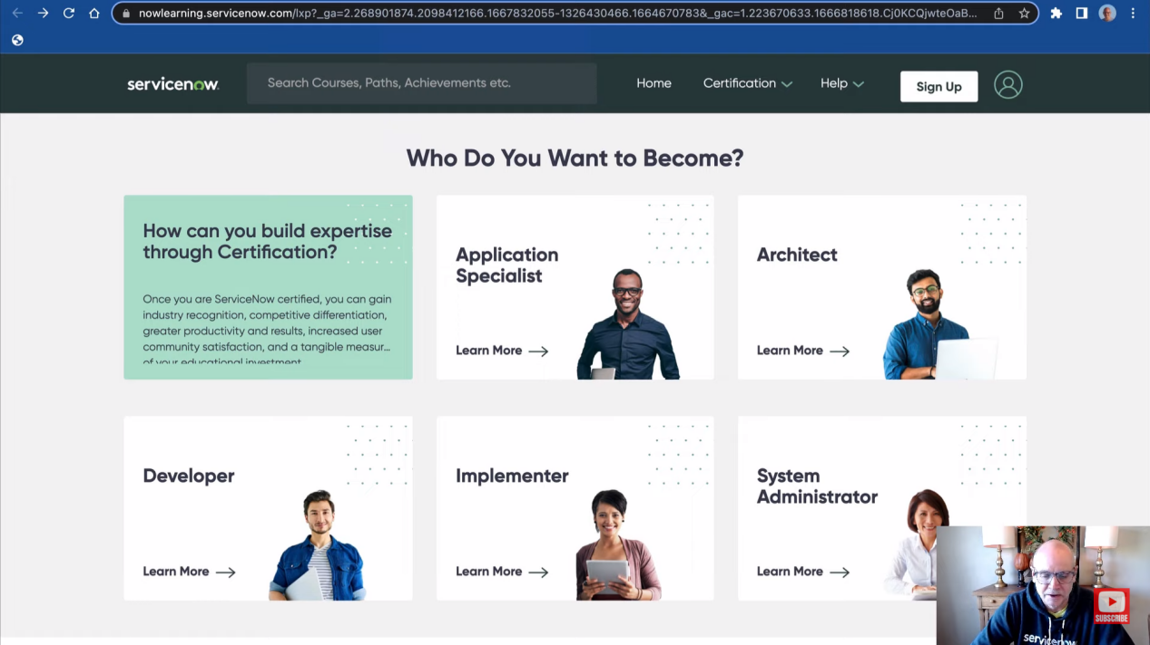

**Working with Lists and Forms Overview :**

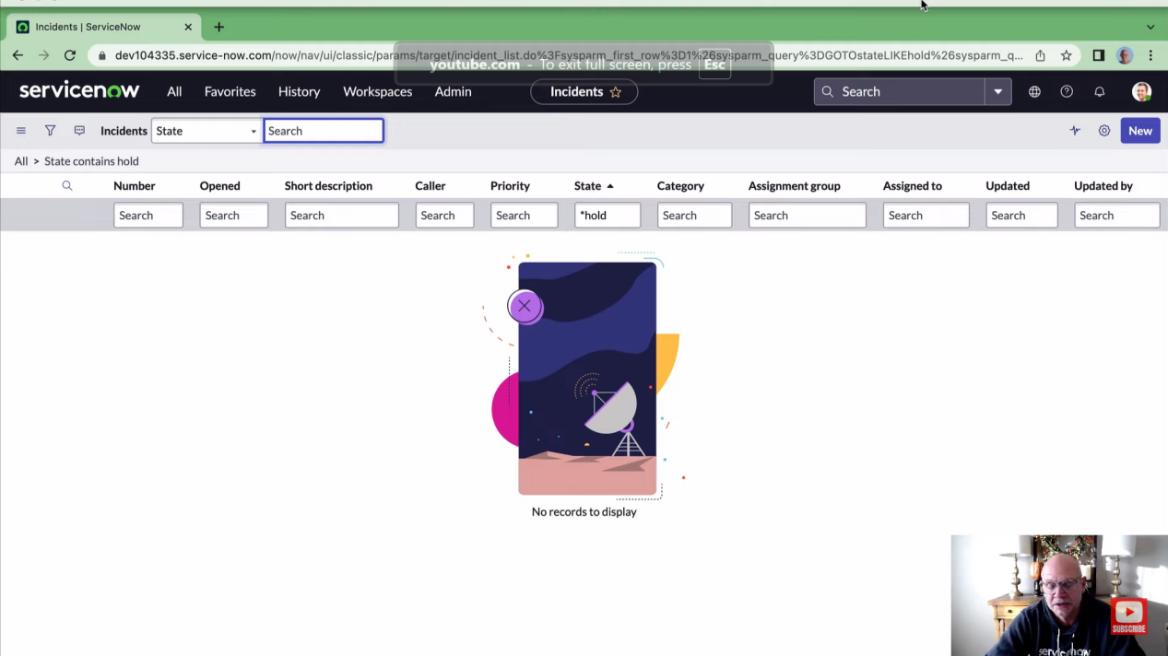

**List Views :**

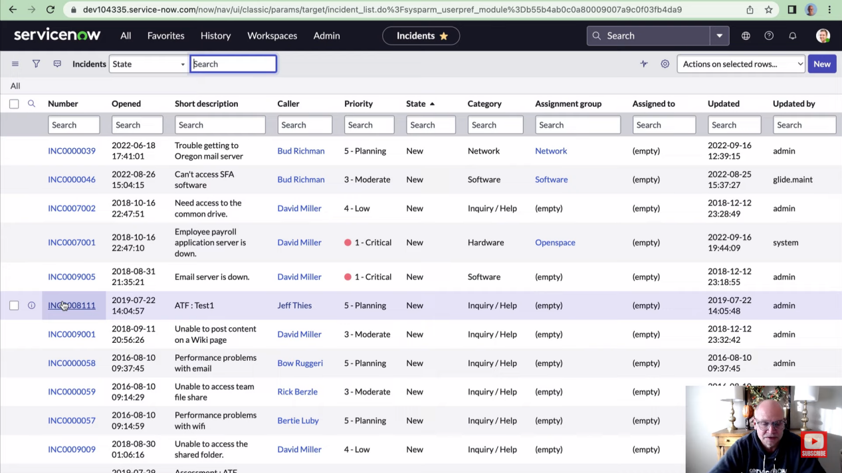

**Form views :**

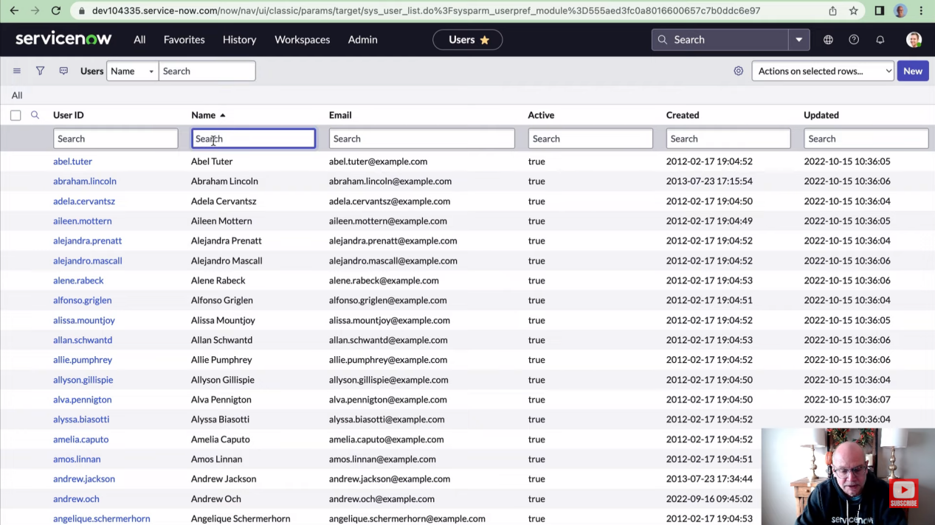

**Knowledge management in ServiceNow :**

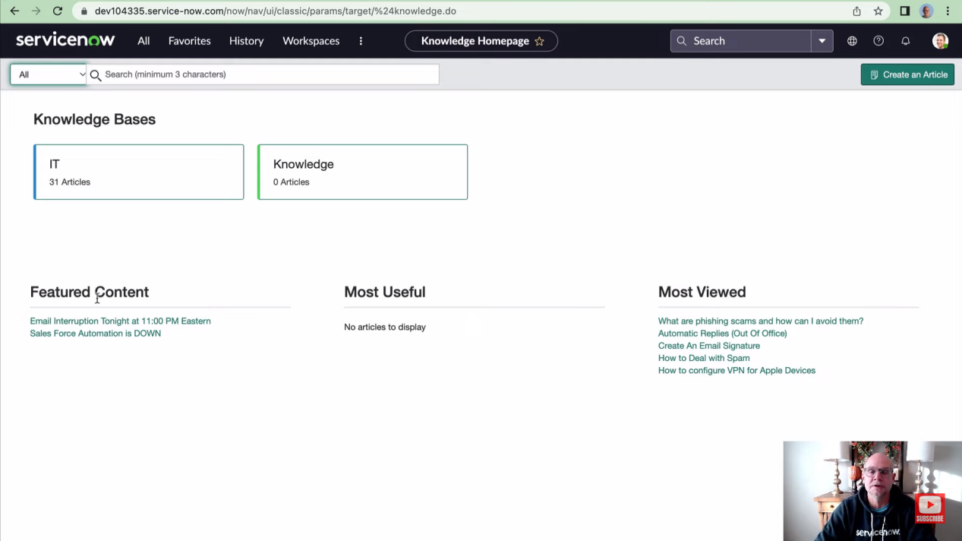

**The ServiceNow Database :**

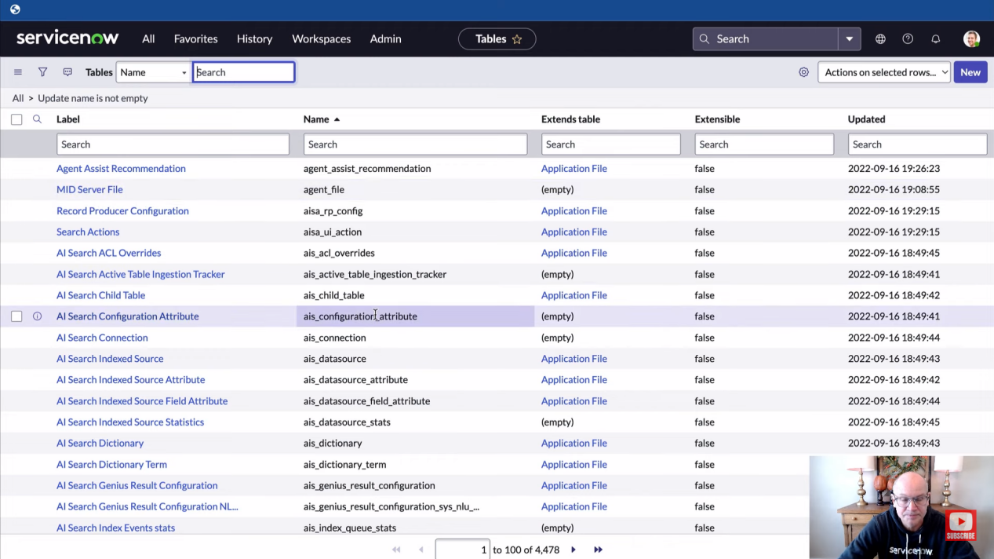

ANANYA CHOUDHARY